Board Game – Semester Project

Innholdsliste
Introduction 2
Preperation and Research 2
Planning 2
What is sockets.io? 2
Sketches 3
Decisions/extensions to the project 4
Tools, frameworks and platform 5
Frameworks 5
Tools and platform 6
Development 7
UX Design 7
Design 8
Code 11
Server 11
Client 13
Testing 15
Hotjar 16
Solved 17
Not Solved 17
Implementation 18
Project 19
Index 19
Lobby 22
Character selection 23
Game 25
Winning 28
Sammendrag 29
Conculsion 29
References 29

Introduction
In this project we are creating a board game with theme from Game of Thrones. In this project we are demonstratoing our knowledge from CSS Frameworks, Javascript 2 and Design 2.

The board game should contain 3 pages:
Character select page
Display 10 characters using the provided API that characters can choose from

Board game page
Providing token for selected character to move around on the board and functinality for playing the game.

The finale page
When a player win the game this game should be viewed declearing a winner. Can use some creativity on this page to make the page exciting.

You can also do the level two process where you need to use sockets.io where two live players connect and play this game together.

Preperation and Research

Planning
Level 1 or Level 2?
First I needed to make up my mind if I should do the level 1 or level 2 process of the assignment.
Sence level 2 require the use of sockets.io I decided that I needed to be familiar with sockets.io so I understood how it would affect my project before I made my decision.

What is sockets.io?
Figuring out how sockets.io worked I did look on youtube and read the documentation and examples on https://socket.io/.
And I will try to explain how it works in simple terms when covering frameworks later in the rapport.
After spending some time getting familiar with the framework I had a understanding of how I wanted to structure my code and how I would acomplish my goals.

Sketches
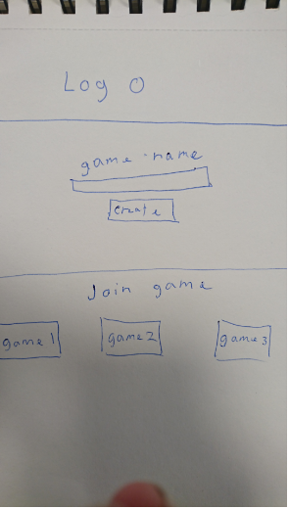
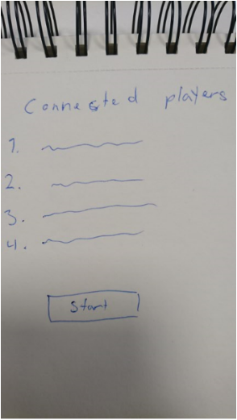
Underneeth are the main page where you can create and join games. And a waiting page where you would be waiting for other players to connect before you start the game.
Underneeth is a character selection screen where you would choose characters and how the game should be. Idea was that if the board was horizontal it was easier to scale for all screen sizes. Like a road the players would need to follow.
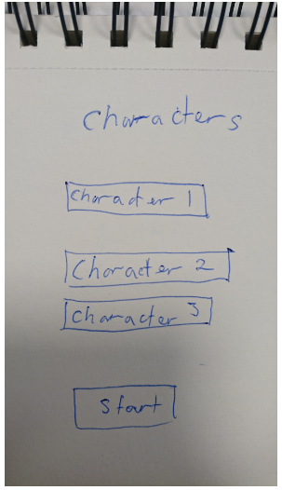
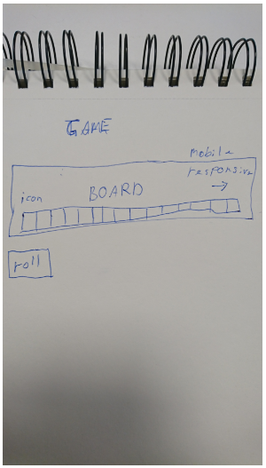

Decisions/extensions to the project
- Game should support up to 10 players
- It should be possible to run multible games at once
- The game itself should be mobile responsive. Does not make sence that everything else is responsive except for the game itself.
- Project will have five pages, but these pages will be made with DOM manipulation instead of seperate html files, because of my knowledge of sockets.io.

Tools, frameworks and platform

Frameworks
Bootstrap
Bootstrap is a css framework that provide a lot of finished written classes making the styling process easier.
Bootstrap is used for structuring code sections and making everything responsive. Dividing content into rows and columns.

Font Awesome
Font Awesome is a css framework providing with a wide selections of font icons that can be used.
In this project font awesome is only used to display the dice during the game.

Express
A node.js web application framework that provide features for web and mobile applications.
For this project I use this framework to initiate a server that I run with sockets.io.

Sockets.io
Sockets.io is a real-time engine that enable bidirectional and event-based communications.
In this project this is used for all communication between server and connected clients.
Example of how to send and recive communication between client and server is shown below.
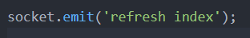

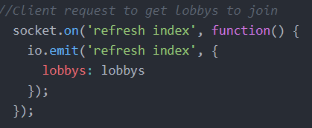

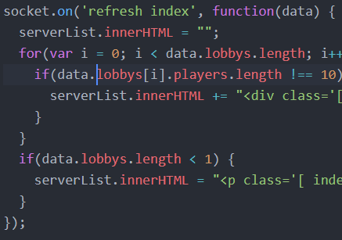

The images above show how the client triggers refresh index event on the server. The server then trigger refresh index event on all the connected clients that all run the same code.

Isomorphic-fetch
Not sure if this could be called a framework. But it adds fetch as a global making it possible to do a API call from server side using a promise.

Nodemon
Nodemon is a framework that makes it easier to develop.
Instead of running “node nodefile.js” I can run “nodemon nodefile.js” and it will restart every time I do any changes.

Sass & BEM
Sass is not a framework but a CSS extension language. Making it a lot easier to structure css and BEM stands for Block – Element – Modifier and is a way to write your css that helps structuring the css.

Tools and platform
Atom
This is my text editor of choice during this project, but there are no reason for me to not use other text editors. It just happen to be the one I used.

PuTTY
I did use PuTTY when trying to run my website on my webpage www.eidesite.com.

FileZilla
FileZilla is a tool where you can use FTP connection to upload files to your domain.

GitHub
GitHub is what I use for my version control system. You can use git to go back to earlier versions of the project if needed. Something I did in order to go back in time and get pictures. It is also a good tool for collabration.

Illustrator
A vector graphic program by adobe.

Development

UX Design
Board Movement and Dice roll
To make it feel like the player actually is moving a piece on a board there is a animation that moves the piece around. This gives the game more a feel that you actually are playing a board game.
For the same reason the dice changes rapidly before it stops. Giving the illusion that the dice rolls.

Responsive Design
When making a game mobile responsive, I think the game should be mobile responsive as well. It would be weird for a user to select a character then suddenly not being responsive anymore.

Filler text, messages
Descriptive buttons, placeholder, titles and descriptions is a important tool to help the players recognizing what is happening.

Availeble games
To join someones game, the games must be availeble for you to see on the main screen. And hiding the games that you should not be able to join to reduce amout of issues that might occur. Hiding a room that has 10 players prevent the issue where there could be games too many players in.

Lobby
When waiting for other players before you start, it is nice to view the players connected before you click the start button.

Viewing other players
When it is not your turn it might get boring. So being able to view from other players point of view while you wait. This waiting time become less boring.

Score
A huge aspect of board games is being able to track who is in the lead and how you are doing during the game. So this information needs to be availeble.

Call to action
By adding color to whatever button that is possible to click on in any given moment helps guide the player on what he or she is supposed to do next. It is also beneficial that this color is a contrast to other colors on the screen.

Design
Color

#554CFF #C8C8C8 #E4E4E4 #FF3232 #404040

#554CFF and a darkened version of this blue color pluss #E4E4E4 is used for button elements and guiding the player.

#C8C8C8 is used to separate elements from the background image so they can be seen properly.

#FF3232 is used to indicate danger spots on the board and error message.

#404040 is used as a background color where game rooms will show later on the index page.

Font

The font is a free to use custom mode made by Charlie Samways.
You can read more about it here: https://fontmeme.com/fonts/game-of-thrones-font/

Spacing
In this project most of the elements are centered to keep the attention of the user. There is also enagh spacing between elements so nothing seems mashed together.

Buttons
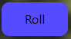
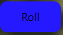

Active Active Hover Inactive

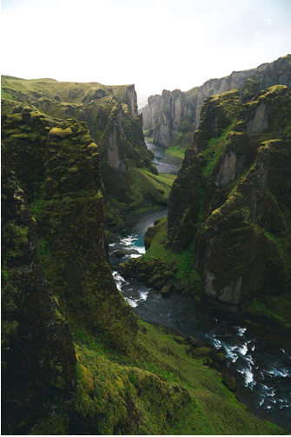
Img
Photo of iceland where game of thrones was filmed.

By:
https://unsplash.com/@jonnyauh?utm_medium=referral&utm_campaign=photographer-credit&utm_content=creditBadge

Icons

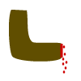
Jamie lannister icon. Eddard Stark icon.
Represent his missing hand. Reprisent his broadsword.



Daenerys Targaryen icon. Arya Stark.
Reperesent the flame from her dragons. Represent her sword Needle.



Cercei Lannister icon. Tywin Lannister icon.
Represent her relationship with others. Represent his death on the toilet when his son shot him with a crossbow.


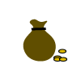
Tyrion Lannister icon. Sansa Stark icon.
Reperesent his role as master of coin. Represent her freedom.


John Snow icon. Joffrey Baratheon icon.
You know nothing John Snow. Represent his crown while he was king.

Logo
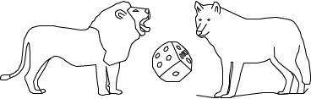
The lion represent the lannisters and the wolf represent the starks.
These are both big houses in the game of thrones universe.
The dice represent the board game itself.

Code

Server
Data
The server side store all of the relevant data to the game. This is to prevent the clients from manipulating the game on the client side. And any manipulation done needs to somehow me manipulated indirectly.

Lobbys[] is an array representing all the games that have not started yet. And therefore will show up on the index page.

Characters[] is an array represeting all the game of thrones characters availeble to choose from, this array is populated as soon as server file is run.

Tiles[] is an array represeting all the tiles in the game and what possibly happens when you land on them, this array is populated as soon as server file is run.

Player is an object that represent all player data and is created for every connection to a new client.

Lobby is created upon connection and represent whatever game the player is connected to.

Classes
There are 4 classes: Tile, Game, Player and Character. Tile is the class used to create new tile objects, Game is the class used to create new game objects. Player is used to create new player objects and Character is used to create new character objects.

API
There is an API call by using a promise on the server side. This API call is wrapped inside a function and when the server starts this is called multible times to add all characters to the characters[] array.

Socket.io
There are multible events that can be triggered on the server side:

connection
A client request connection to the server.

disconnect
Cleint request disconnect from server

refresh index
Cleint request to refresh index (games available) for all clients connected.

join lobby
Client request to join a game.

create lobby
Client request to create a new game.

character selection screen
Client request that game he is in should go over to the character selection screen and therefore not be availeble to join any longer.

select character
Client tells server it has chosen a character and next player will be asked to choose a character, if all have selected start the game.

roll
A client have requested to roll the dice and all clients will recive a response to execute this roll.

check tile
Client want to check what tile the pice landed on, was it a dubble roll or did player land on a tile that gives any kind of punishment?

next turn
Client request that next player should have his turn.

Client
window resize
On window resize canvas will be resized and board will be generated again.

Socket.io
There are multible events that can be triggered on the client side:

refresh index
Server tell client to update what games are available to join.

refresh lobby
Server tell client to update what other clients are connected to the same game in lobby.

character selection screen
Server tell client to show the character selection page.

next character select
Server tell client who are to select next character

start game
Server tell client to start the game page.

move player
Server tell the client to move the player on the board.

next turn
Server tell the client to switch to next player.

roll again
Server tell the client that current player get to roll again.

next trigger
Server tell client that turn has ended and that current player are allowed to end his or her turn.

Alert
Server tells the client to display an error.

winning
Server tells the client to display the winning page.

Functions
On client side buttons can trigger these functions.

joinLobby
Will trigger server event to join a game.

createLobby
Will trigger server event to create a game.

characterScreen
Will trigger server event to start character selection.

SelectCharacter
Will trigger server event for selected character.

rollDice
Will trigger server event for rolling the dice.

endTurn
Will trigger server event to end players turn.

drawBoard
Will draw the board in canvas.

animateBoard
Will animate movement in canvas where player moves one tile.

displayNext
Will display who got the next turn in canvas.

HTML & CSS
There are just one html file in this project. But the client side does do a lot of DOM manipulation where current content will be removed from the page and generate new html using DOM manipulation witch will produce a new page.

The javascript does also remove and add css classes to elements in order to display them correctly during gameplay.

Testing
When developing the project. Martin did test the project multible times for functinality to see if everything works as intended. Svenn and Jonas doing a simular project did also suggested some improvements or pointed out bugs.
There were also some minor assistance and suggestions from noroff emplyees Rene and Eivind during the project.
When being able to host the project on my domain www.eidesite.com. Project was tested there as well from family members.

Hotjar
Hotjar was implimented on this project and there were some responses from older family members that were unexpected and a bit intesresting.
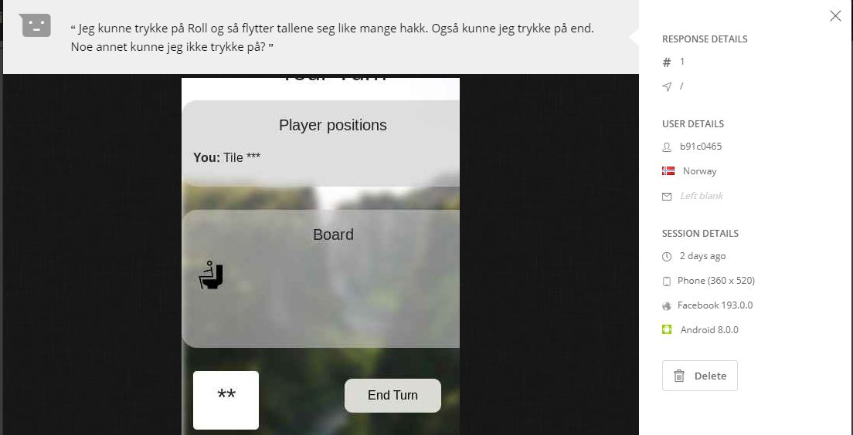
Above you can see what the user explain he or she is able to click on roll and end turn, and asking if there is supposed to be anything else you could click on. You could assume the user find the game a bit boring and might want slightly more functinality.
In hotjar some info seem to be censored and canvas is hidden as shown in the image above.
Here is another feedback explaing he were able to finish the game.
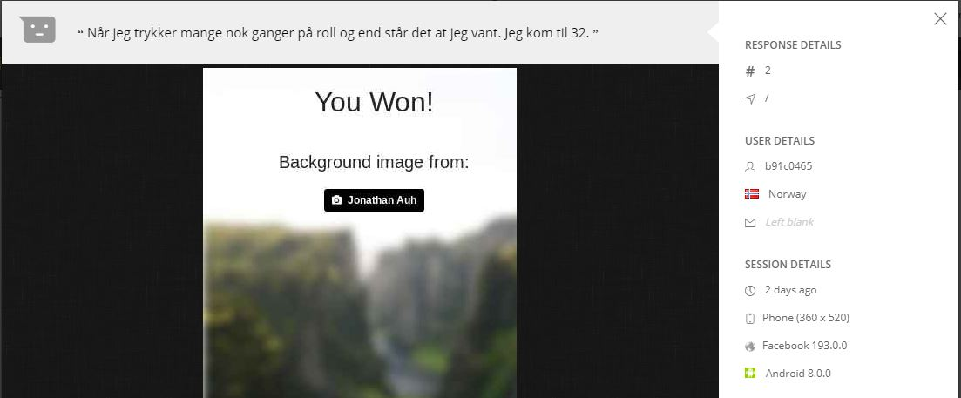
Another issue with hotjar in this project was looking at the heatmap. Because you would only see the static index page on the heatmap because of all the dom manipulation. And heatmap is also not accurate because most of the data gathered is from the developer of the page doing testing.

Solved
Based on feedback these issues were solved:
- Socket id is not visible in the lobby, because it does not give user any information other than confusion.
- Add placeholder and better description on buttons to better guide the player through the game and other messages describing what to do.
- Align end button with roll button on the game page.
- When rolling the dice it display dice instead of numbers.
- Button color to indicate what you can do next.
- Red color on board to indicate punishing tiles.
- Where you can join other games there are showing a message when there are no games to join. Indicating what it is for the player.

Not Solved
More information on every tile to be more informative to the player
Adding this information within every tile in the game will make it cluttered and might be more confusing than helpful.
Adding hover functinality might be an ide. But found no good solution to do this when using canvas.

Loadmask when waiting for server response
When hosting on website there is slow responsetime between client and server that makes the game annoying.
A solution could be to display a loadmask while waiting for responses. The challenge with this is that client is waiting for server response in many different senarios and you would have to figure out how to impliment this loadmask in all the different senarios where this issue might occur.
But this might have been doable if there was more time.

More messages/errors
There have been added more indicators during development. But there could also be more indicators like messages and errors telling players what is going wrong or what is happening next.

Implementation
When running this project on eidesite.com, node need to be installed on the host and node need to be run on the page using a ssh connection. Were not able to figure out how to keep the process running after closing the ssh connection. There were multible suggestions on how to run the process in the background online, but nothing was working and in the end came to a conculsion that this was not nessesary for this project.

Project
Below shows the different pages and how the pages have developed over time.

Index

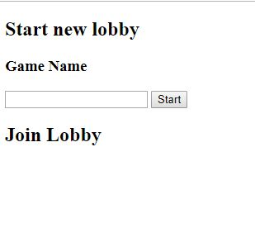
Version 1

Version 2
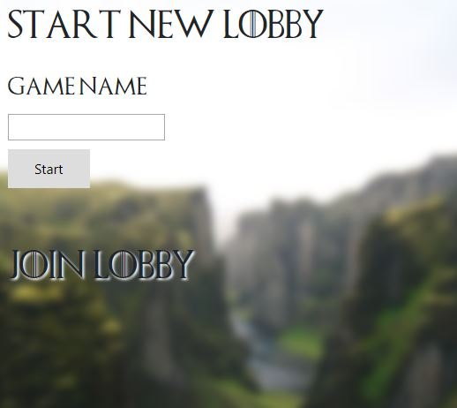

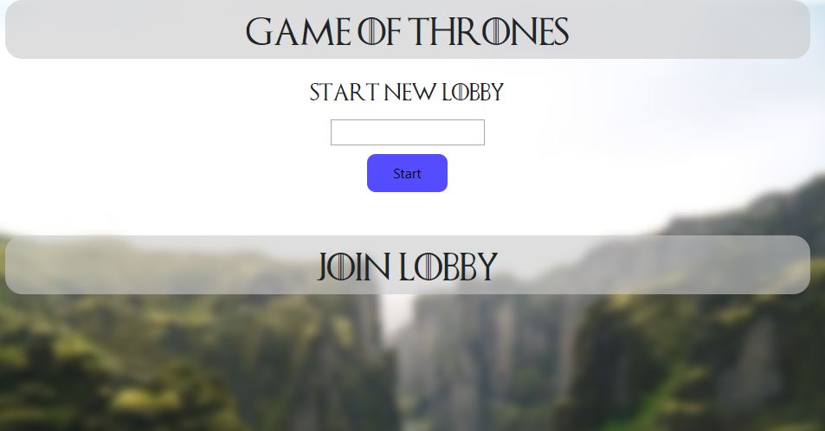
Version 3
Version 4
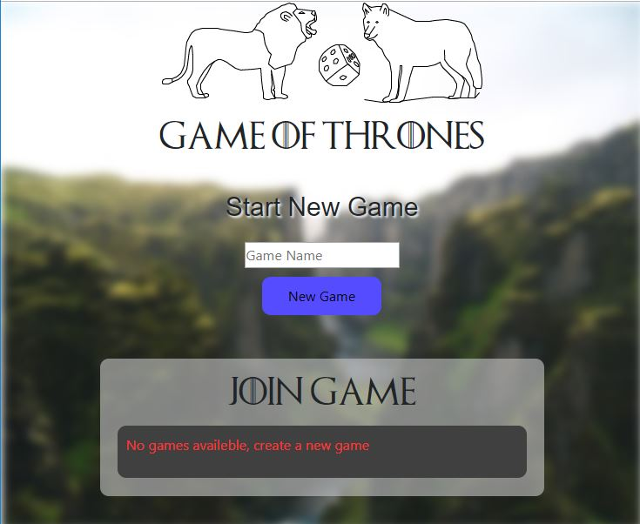

Lobby

Version 1
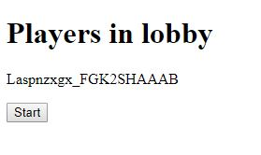
Version 2
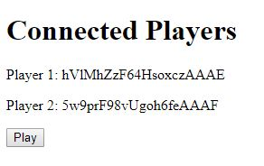

Version 3

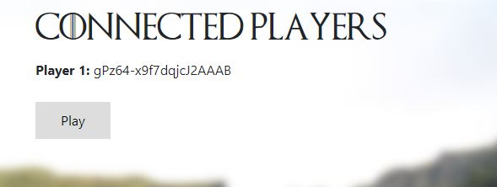

Version 4

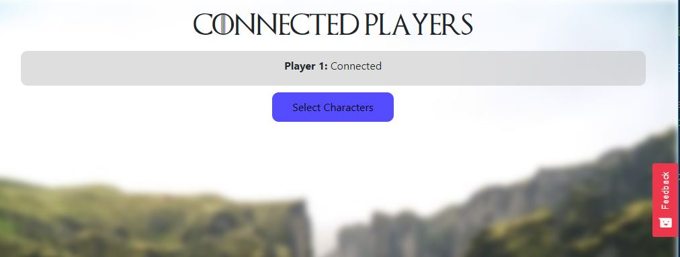

Character selection

Version 1
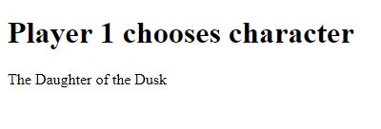

Version 2
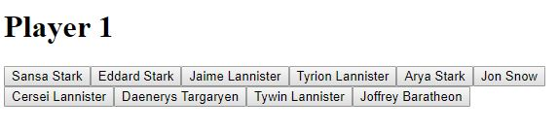

Version 3
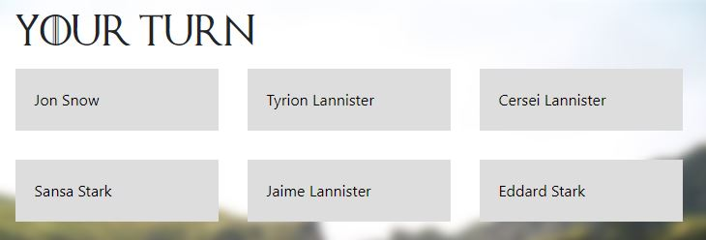

Version 4
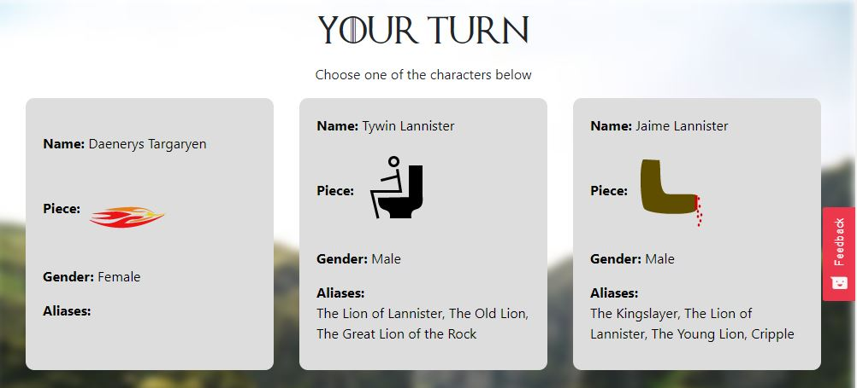

Game

Version 1

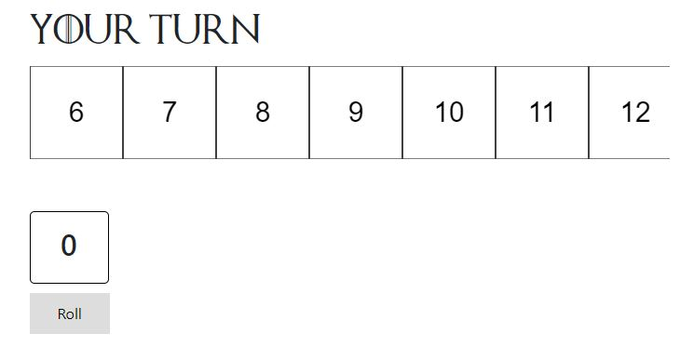

Version 2
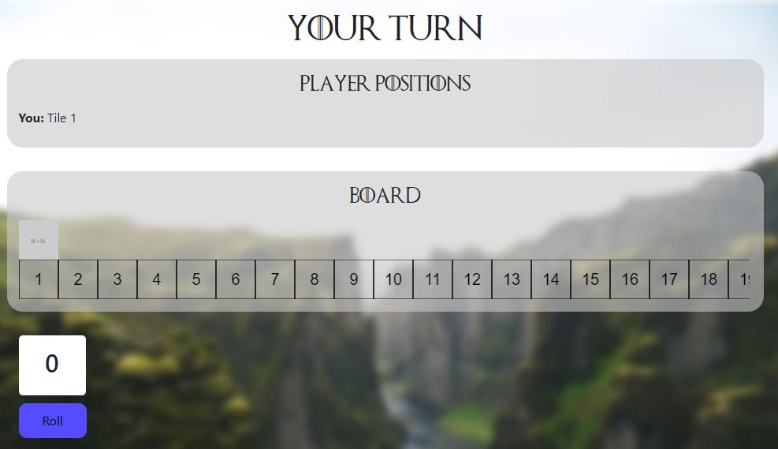

Version 3
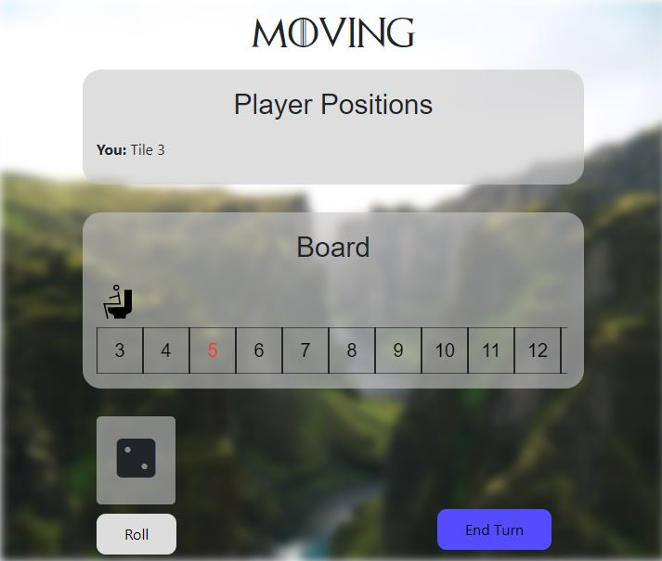

Winning
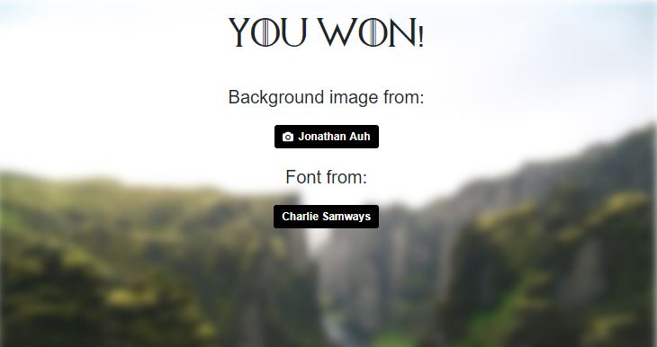

Sammendrag
This rapport go through the task itself and what decisions that were made beforehand to get to a good solution.
There is a explonation on what tools that were used during the entire project and what the tools are and what they were used for.
After explaining the project and how to go about the project and what tools that are used in order to solve it the raport go in details about the development process. The development process include details on what was done to create a good user experience, what design choices were made and how the code is organized and structured.
The testing of the website was done with the use of hotjar and by the help of other people the developer got in contact with and there are detailed descriptions on what was done about these issues and what could have been done better or improved given more time. Becuase there are always something that can be improved.
The end of the rapport there are pictures showing how each of the pages developed from the beginning to the end of the project.

Conculsion
I think what is described on the “not solved” part of the rapport is things that could have been improved, but considering the scope of the project is fine without.
Being the first time working with a lot of these frameworks it has been a project where I have learned a lot, there are probebly better practices on how to work with these frameworks that I am not aware of something that has been hard getting feedback on during this project. Sence few seem to have experience with these frameworks.
When implementing the webpage to website eidesite.com. The project behave very intermittent and slow. I suspect that being caused by the hosting service for the website and not the code.
The design seem a bit boring, but might just be the time spent on the project that makes the site seem a bit boring.

Overall I am very satisfied with the project and I belive I have mastered a lot of new things during the project.

References
Unsplash.com(2018), Jonathan Auh(@jonnyauh) | Unsplaish Photo Community, Availeble at:
https://unsplash.com/@jonnyauh?utm_medium=referral&utm_campaign=photographer-credit&utm_content=creditBadge
Fontmeme.com, Game of Thrones Font Download, Availeble at: https://fontmeme.com/fonts/game-of-thrones-font/

